Usability is crucial in web application design. If a user doesn't have a good interaction with the web application then they will not use it

**First Post**  
Research and list at least 3 best practices when it comes to **usability**. Review your Course Project website and determine whether you’ve addressed these practices. Share 2-3 snapshots of your site in your post.

**Reply Post**  
In your response, select one classmate’s post, and make at least one additional usability recommendation. Notate these recommendations using your classmate’s screenshots to illustrate the examples

Post

The credibility of a website is a key factor in a websites usability. According to (Fadeyev, 2009) “users really do judge a book by its cover… or rather, a website by its design”. He states the following elements are crucial for the usability and the image your website projects:

* Layout
* Consistency
* Typography
* Color
* Style
* Content
* Amount of errors
* Rate of updates
* Ease of use
* Trustworthiness of authors

My class project website is very consistent. Each page has the same navigation setup, layout and color theme. Each page is utilizes whitespace and allows the users to focus on key content to limit confusion.

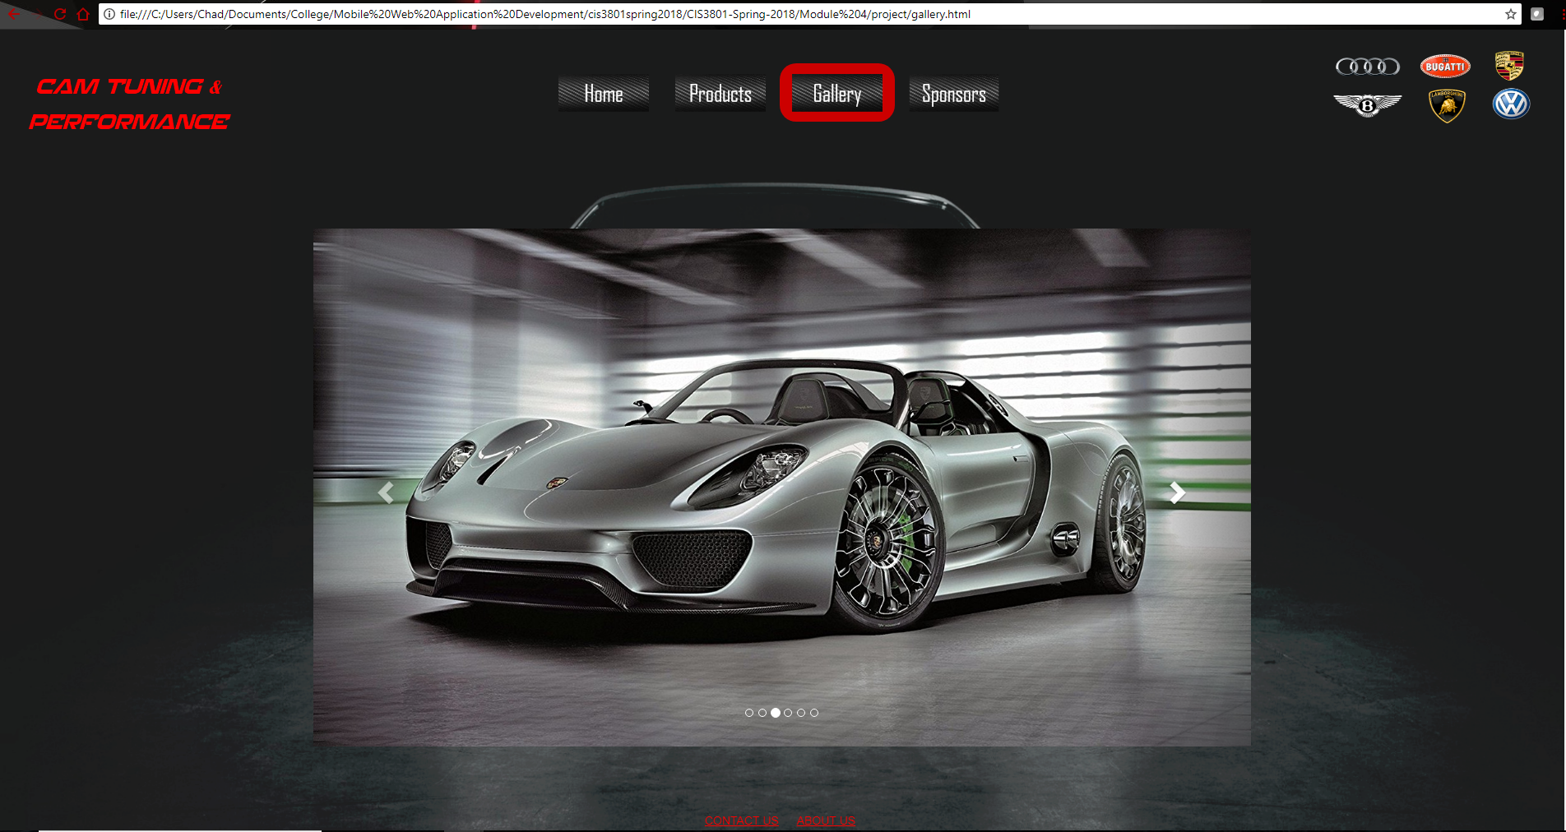

An interesting study by (Nielsen, 2006) points out the users are less likely to scroll down a website on their first visit to the page. Meaning the area that is being displayed on their device should contain all vital content for the website to engage the user to stick around. This is a balancing act as you do not want to overload the home page but rather utilize whitespace and provide relevant content to enhance usability. My class project home page is very simplistic in nature and entices the user to enter their vehicle configuration right away. The background is engaging as well and sets the tone of the website.

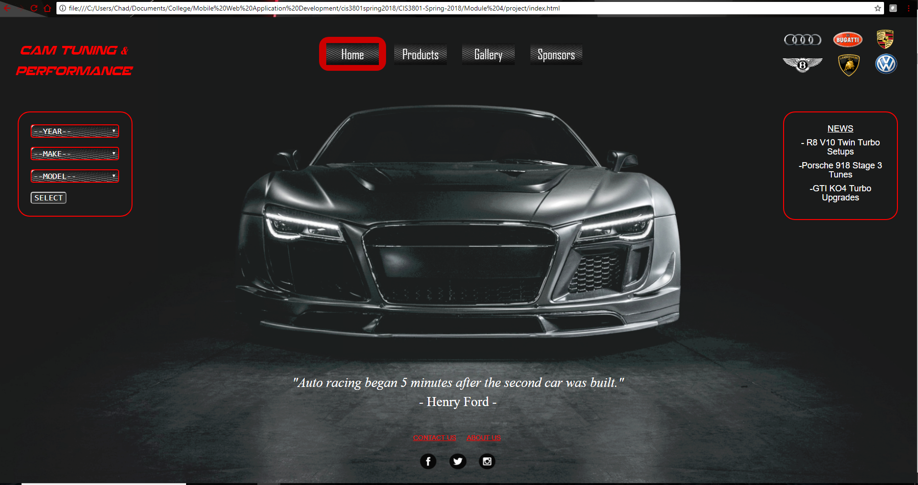

Finally confusing product pages will likely lead to a loss in sales as users will exit the site in frustration and go elsewhere for their purchases. According to (Prioritizing Web Usability, 2018) “Research shows that poor product information accounts for around 8% of usability problems and even 10% of user failure”. For my class project I designed my product page to have large icons that are easily identifiable with good amount of white spacing. This should help the user make their selection fast without confusion.

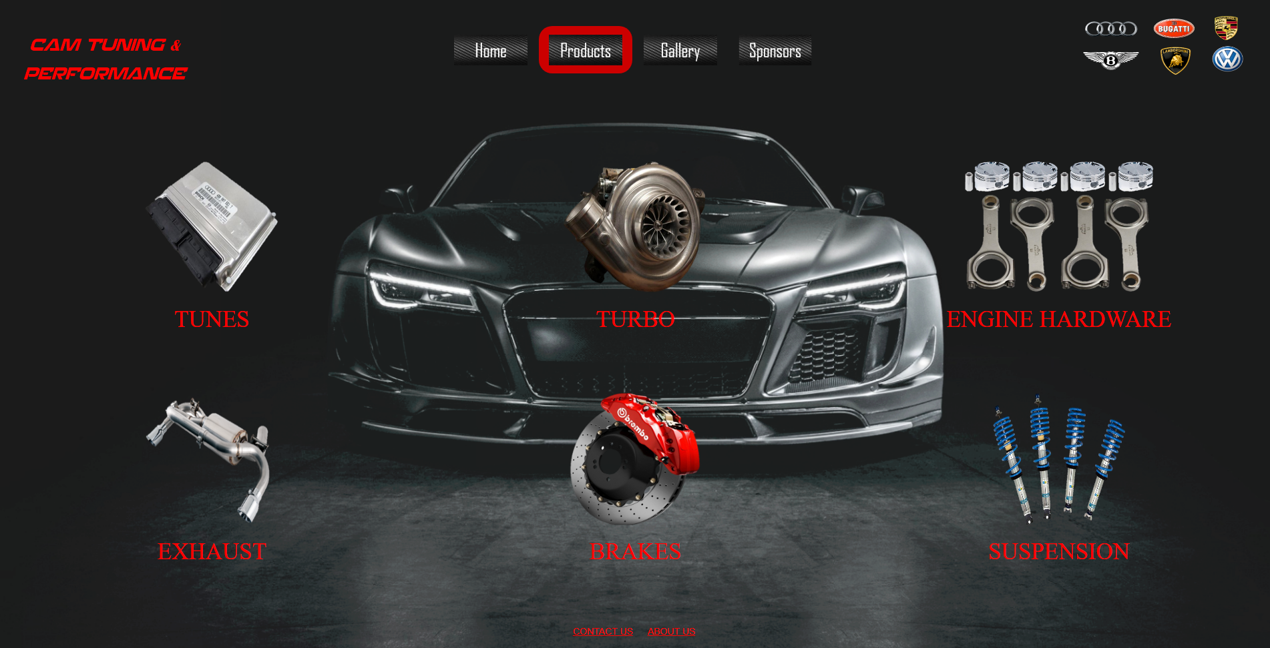

References:

<https://www.smashingmagazine.com/2009/09/10-useful-usability-findings-and-guidelines/>

<https://www.nngroup.com/books/prioritizing-web-usability/>